**TABLE OF CONTENTS**

|  |  |
| --- | --- |
| **Title** | **Page Nos.** |
| Executive Summary | i |
| List of Tables | ii |
| List of Graphs | iii |
| Chapter 1: Introduction and Background | 1-5 |
| Chapter 2: Research Methodology | 6-10 |
| Chapter 3: Data Analysis and Interpretation | 11-19 |
| References |  |
| Annexures |  |
|  |  |

|  |  |  |
| --- | --- | --- |
| **List of Graphs** | | |
| **Graph No.** | **Graph Title** | **Page No.** |
| 1 | Screenshot of data upload | 8 |
| 2 | Screenshot of Missing values | 9 |
| 3 | Screenshot of Heatmap missing values | 12 |
| 4 | Screenshot of Corelation Matrix | 16 |
| 5 | Screenshot of ROC Curve | 19 |
|  |  |  |

**CHAPTER 1**

**INTRODUCTION AND BACKGROUND**

**INTRODUCTION AND BACKGROUND**

* 1. **Executive Summary**
  2. **Introduction and Background**
  3. **Problem Statement**
  4. **Objective of Study**
  5. **Company and industry overview**
  6. **Overview of Theoretical Concepts**

**1.1** **EXECUTIVE SUMMARY**

This research focuses on addressing the critical issue of customer churn in the highly competitive DTH sector . With the growing challenges in retaining customers, it has become imperative for companies to leverage advanced predictive analytics to anticipate churn risks. This study carves out a niche by developing a machine learning-based model for predicting customer churn, utilizing a rich dataset comprising various customer interactions, transactions, and behavioural patterns. The aim is to not only predict potential churners with high accuracy but also to provide actionable insights that can be integrated into strategic decision-making processes for improving customer retention.

* 1. **Introduction and Background**

DTH, which stands for Direct-to-Home, is a digital satellite service that provides television services directly to subscribers through satellite transmission anywhere in the country. The service is received directly by the consumer through the small dish antennas and set-top boxes installed at the subscriber's premises. This system eliminates the need for a conventional cable service or terrestrial broadcast options, offering high-quality audio and video to even the most remote locations.

# 1.3 Defining the Problem Statement

Customer churn, which refers to the loss of clients or customers, poses a significant challenge for companies, particularly in the service industry where customer retention is crucial to sustaining revenue and growth. In the context of the provided dataset, understanding the factors that lead customers to leave can help in developing targeted strategies to improve customer satisfaction and loyalty. By analyzing customer behavior, service usage, payment methods, and interaction with customer care, we aim to identify patterns and predictors of churn.

# 1.4 Objective of the Study/Project

Addressing customer churn is vital for several reasons:

Financial Impact: Retaining an existing customer is generally more cost-effective than acquiring a new one. Reducing churn rates can lead to significant cost savings and increased profitability.

Customer Lifetime Value: Customers who stay longer are more valuable over time, not just through direct transactions but through referrals and enhanced reputation.

Service Improvement: Understanding the reasons behind churn can highlight areas where the service can be improved, leading to higher customer satisfaction.

* 1. **Company and industry overview**

Revenue in the DTH industry is generated through various streams, including:

1. **Subscription Fees**: The primary revenue source for DTH providers is the monthly or annual subscription fees paid by customers to access a bundle of channels. These packages can vary greatly in terms of the number of channels and the type of content provided, from basic packages to premium offerings that include high-definition channels, international channels, or exclusive content.
2. **Pay-Per-View (PPV) and Video on Demand (VoD)**: DTH operators offer special content on a pay-per-view basis, such as new movie releases, special sporting events, or concerts, where subscribers pay an additional fee to watch a specific event or movie.
3. **Sale and Rental of Equipment**: DTH providers also generate revenue from the sale or rental of necessary equipment to subscribers, such as the satellite dish, set-top boxes, and sometimes additional accessories required for the setup.
4. **Value-Added Services (VAS)**: These include interactive services, internet access, games, learning applications, and other multimedia content offered over the DTH platform, for which subscribers pay extra.
5. **Advertising**: Some DTH operators have channels that feature advertisements, or they offer advertising opportunities in their interactive services, contributing to their revenue.
6. **Channel Carriage Fees**: DTH operators may charge broadcasters channel carriage fees for carrying their channels on the DTH platform, which is a significant revenue stream in some markets.
   1. **Overview of Theoretical Concepts**

The rise of Over-The-Top (OTT) streaming services has significantly impacted the Direct-to-Home (DTH) industry, affecting it in several key ways:

1. **Competition for Viewers**: OTT platforms like Netflix, Amazon Prime Video, Disney+, and others offer a vast library of on-demand content, including movies, TV shows, documentaries, and exclusive series, directly over the internet. This has led to stiff competition for DTH services, as viewers now have more choices than ever for their entertainment needs. The convenience of watching content anytime, anywhere, without the need for a satellite dish or specific hardware, is a significant draw for many consumers towards OTT services.
2. **Shift in Viewing Habits**: There has been a noticeable shift in how people consume media, with a growing preference for streaming services over traditional TV viewing. The younger demographics, in particular, favor OTT platforms for their content consumption, leading to a decrease in DTH subscriptions among these age groups. This trend has forced DTH providers to reassess their service offerings and pricing models.
3. **Demand for Bundled Services**: To remain competitive, some DTH operators have started offering bundled services that include both traditional satellite TV and OTT subscriptions. This approach aims to provide more value to subscribers and counter the appeal of standalone OTT services. Bundling also helps in retaining customers who might be considering cutting the DTH cord in favor of exclusive OTT subscriptions.
4. **Pressure to Innovate and Improve Content Offering**: The popularity of OTT services has put pressure on DTH providers to enhance their content offerings and improve the user experience. This includes investing in better technology, offering high-definition and ultra-high-definition channels, interactive services, and expanding their on-demand content libraries.
5. **Changes in Revenue Models**: The growth of OTT platforms has also influenced the revenue models of DTH operators. With the increasing competition, DTH services may face challenges in maintaining their subscription rates and are pushed to explore alternative revenue streams, such as advertising, partnerships with OTT platforms, and introducing their OTT services.
6. **Regulatory Challenges and Opportunities**: The regulatory environment for OTT services differs significantly from that of DTH and traditional broadcasting. This discrepancy can sometimes provide OTT platforms with a competitive advantage, prompting calls for regulatory reforms to create a level playing field.

In conclusion, the rise of OTT services has disrupted the traditional television and DTH industries by changing consumer expectations and viewing habits. To stay relevant, DTH operators are adapting by enhancing their offerings, partnering with OTT platforms, and exploring new business models. The future of DTH may well depend on how effectively it can integrate with the broader digital entertainment ecosystem.

**CHAPTER 2**

**Research Methodology**

**RESEARCH METHODOLOGY**

**2.1 Scope of the Study**

**2.2 Methodology**

**2.2.1 Research Design**

**2.2.2 Data Collection**

**2.2.3 Sampling Method (if applicable)**

**2.2.4 Data Analysis Tools**

**2.3 Period of Study**

**2.4 Utility of Research**

# 1. Data Loading and Preliminary Inspection

First, we'll load the data from the Excel file and perform a preliminary inspection to understand the basic structure of the dataset (number of rows, columns, and a preview of its content).

Load the data :

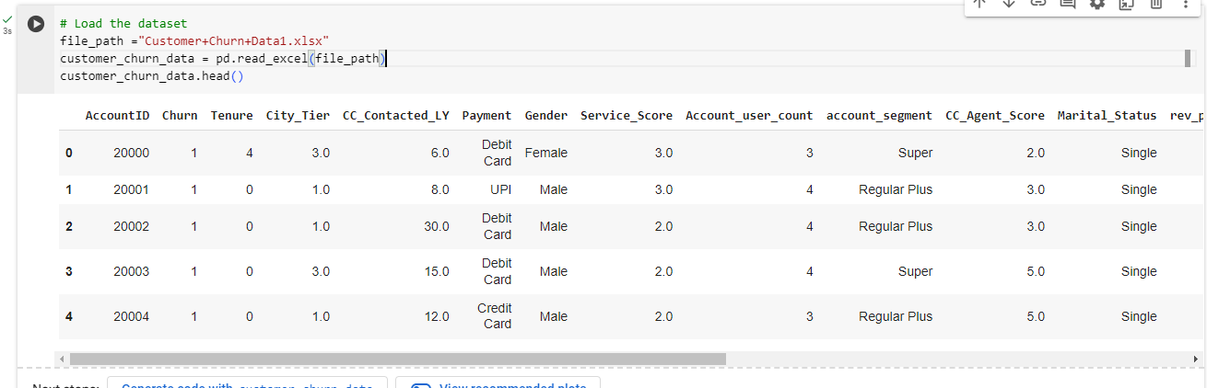

Graph No. 1

Data Inspection Summary

The dataset consists of 11,260 entries and 19 attributes. Here’s a brief overview of the columns:

AccountID: Identifier for the customer account.

Churn: Indicates whether the customer churned (1) or not (0).

Tenure: The number of years a customer has been with the company.

City_Tier: Classification of cities into tiers based on size and economic factors.

CC_Contacted_LY: Number of times customer contacted customer care last year.

Payment: Preferred payment method (e.g., Debit Card, UPI, Credit Card).

Gender: Gender of the account holder.

Service_Score: A score indicating the quality of service perceived by the customer.

Account_user_count: Number of users on the account.

Account_segment: Category of the account based on its characteristics (e.g., Super, Regular Plus).

CC_Agent_Score: Score reflecting the performance of the customer care agent.

Marital_Status: Marital status of the account holder.

Rev_per_month: Revenue per month from the customer.

Complain_ly: Indicates whether the customer had a complaint in the last year.

Rev_growth_yoy: Year-over-year revenue growth.

Coupon_used_for_payment: Indicates if coupons were used for payment.

Day_Since_CC_connect: Days since last customer care contact.

Cashback: Cashback amount received by the customer.

Login_device: Device used to log into the service.

Data Quality Issues Noted:

**There are missing values across several columns.**

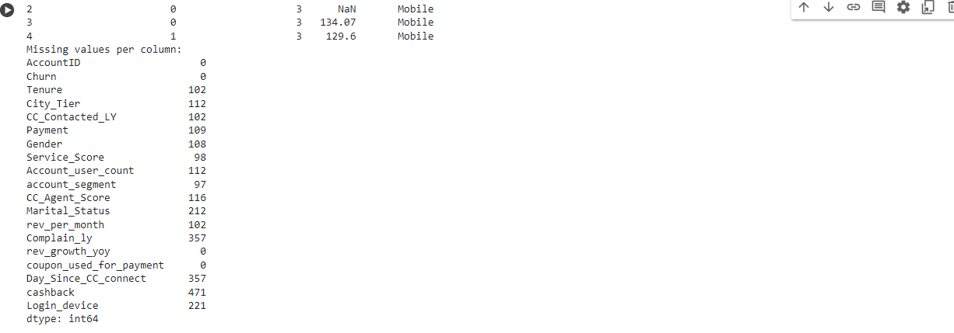

**Graph No. 2**

Data types for some columns like Tenure, Account_user_count, Rev_per_month, and others appear to be object types that might need conversion for proper analysis.

Potential inconsistencies in data entry (e.g., numeric values stored as strings).

**CHAPTER 3**

**DATA ANALYSIS AND INTERPRETATION**

**DATA ANALYSIS AND INTERPRETATION**

Based on the preliminary inspection, the dataset consists of 11,260 entries across 19 attributes related to customer accounts and interactions. A more detailed visual inspection can help identify discrepancies, missing data, and potential redundancies.

Visual Tools to be Used:

Histograms for distribution insights on continuous variables like Service_Score, CC_Agent_Score, and rev_per_month.

Bar charts for categorical data analysis such as City_Tier, Gender, and Marital_Status.

Heatmaps to visualize missing data patterns, helping to prioritize data cleaning efforts.

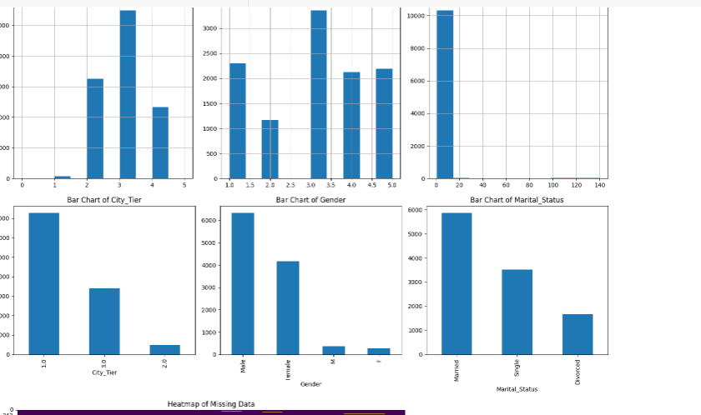

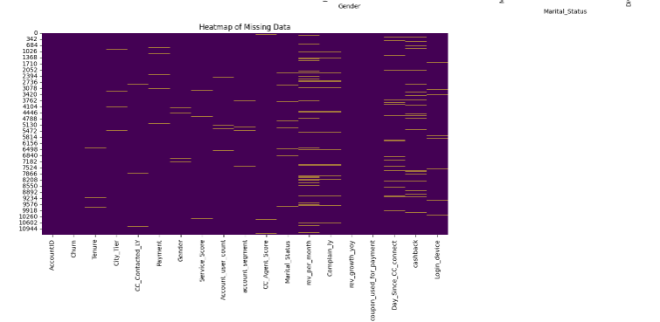

**Graph No. 3**

c) Understanding of attributes (variable info, renaming if required)

Here, we'll clarify each attribute's role in the dataset, propose any necessary renaming for clarity, and decide on data type conversions.

Example :

Tenure (convert to integer): Represents the length of time the customer has been with the service, presumably in years.

City_Tier (integer is suitable): Indicates the economic tier of the city the customer resides in, which might affect service usage patterns.

**Data Cleaning and Preparation in Python**

Convert Data Types: As identified in the data report, certain columns are stored as objects but should be numeric or integer for accurate analysis.

Handle Missing Values: We'll examine the distribution of missing values and apply appropriate techniques to handle them, such as imputation or removal, depending on the context.

Renaming Variables: If necessary, rename columns for clarity and ease of use in analysis.

Initial Data Quality Check: Identify any outliers or anomalous entries that could skew analysis results.

Step 1: Convert Data Types

Step 2: Handle Missing Values

We'll check for missing values and decide on an appropriate method for each column based on the type of data and the proportion of missing data.

Step 3: Initial Data Quality Check

We'll briefly check for outliers using a simple statistical method (e.g., Z-scores or IQR).

**Data Cleaning and Preparation Summary**

Here's an overview of the actions taken and the current state of the dataset:

Data Type Conversions

We successfully converted several columns (Tenure, Account_user_count, Revenue_Per_Month, Day_Since_CC_connect, cashback) to appropriate numeric types, which will facilitate further analysis.

Missing Values

All missing values have been addressed:

Numerical columns were filled with their respective medians.

Categorical columns were filled using the mode (most frequent value).

Renaming Variables

Columns have been renamed for better clarity, such as:

CC_Contacted_LY to CustomerCare_Contacts_LastYear

rev_per_month to Revenue_Per_Month

Outliers

Outlier detection was conducted using the Interquartile Range (IQR) method. Here are some findings:

Account_user_count has 761 outliers.

Churn shows 1,896 outliers, which likely indicate that this is a binary variable with a disproportionate class distribution.

cashback has 986 outliers, suggesting significant variation in cashback amounts.

**Exploratory Data Analysis (EDA):** Begin with univariate and bivariate analysis to understand distributions, relationships, and group dynamics within the data.

Advanced Cleaning: Depending on the EDA results, further cleaning may be needed, particularly in handling the outliers more appropriately.

Preliminary Insights: Start forming preliminary insights based on the cleaned data, focusing on factors that might influence customer churn.

Exploratory Data Analysis (EDA) in Python

# 1. Univariate Analysis

We will analyze the distribution and spread of each variable to get a sense of the data's characteristics.

Histograms for continuous variables to understand distributions.

Bar charts for categorical variables to see frequency counts.

# 2. Bivariate Analysis

We'll explore relationships between different variables, particularly focusing on how they relate to the Churn variable.

Correlation Matrix: To identify relationships between numerical variables.

Boxplots and Scatter plots: To visualize relationships between categorical and continuous variables respectively with Churn.

# 3. Advanced Analysis

Remove Unwanted Variables: Identify any variables that do not contribute to the analysis or have redundant information.

Missing Value Treatment: Reassess if further treatment is needed after initial handling.

Outlier Treatment: Consider methods to handle outliers if they can significantly impact model accuracy.

Variable Transformation: Apply transformations to variables to improve model fitting, if necessary.

**Exploratory Data Analysis Results**

Univariate Analysis

Continuous Variables: The histograms show the distributions of variables such as Tenure, Revenue_Per_Month, CustomerCare_Contacts_LastYear, Service_Score, and cashback. Each shows varying degrees of skewness and kurtosis, providing insights into how spread out these attributes are across the customer base.

Categorical Variables: Bar charts for City_Tier, Gender, Marital_Status, and account_segment illustrate the frequency of each category. For instance, some tiers or segments may have more customers, which can be critical for targeted marketing strategies.

Bivariate Analysis

Correlation Matrix: The heatmap displays correlations between numerical variables. Key observations could include high or low correlations between features like Revenue_Per_Month and Tenure, which might indicate long-term customers generate more revenue. Such relationships are vital for understanding factors that may influence churn.

**Key Observations:**

Certain variables might need transformations due to skewness to better fit predictive models.

Categorical data distribution suggests exploring relationships between these categories and churn could yield meaningful insights.

Some features show potential interdependencies, suggesting multicollinearity checks before model building.

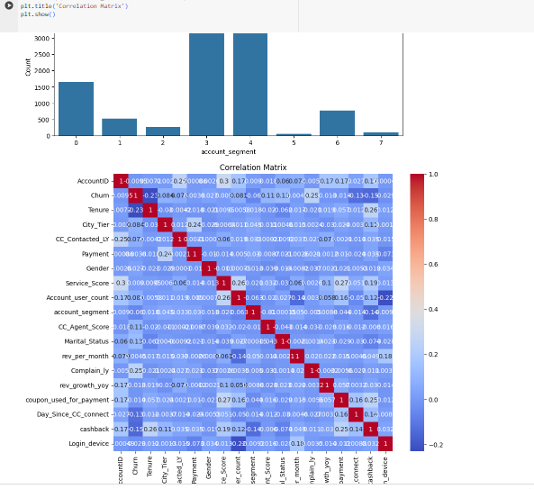

**Graph No. 4**

Let’s proceed with the advanced data analysis and prepare the dataset for modeling. This will involve dealing with outliers, potential multicollinearity, and enhancing our dataset through feature engineering.

**Advanced Data Analysis and Preparation for Modeling**

**Outlier Treatment**

We've capped outliers in Tenure, Revenue_Per_Month, CustomerCare_Contacts_LastYear, and cashback based on the 1st and 99th percentiles, which helps in mitigating the influence of extreme values on our analysis.

**Variable Transformation**

The log transformation applied to Revenue_Per_Month (now log_Revenue) helps normalize the distribution, which is beneficial for many modeling techniques that assume normality of the input variables.

**Feature Engineering**

We created a new feature, Complaints_to_Contacts, which might provide insight into how frequently a customer complains relative to their interactions with customer service—a potentially strong predictor of churn.

**Multicollinearity Check**

The updated correlation matrix was displayed, allowing us to see how our new features correlate with other variables and with each other. This step ensures that we don't include highly correlated predictors in the same model, which can distort the significance and effectiveness of the model.

**Dataset Split**

The data has been split into training and testing sets, with 80% of the data used for training and 20% for validation. This split helps in training models on a large subset of data while reserving a portion for unbiased evaluation of model performance.

**Model Building**

Logistic Regression: A baseline for binary classification tasks.

Random Forest Classifier: A robust method that handles non-linearities well and provides importance of features.

Gradient Boosting Machine (GBM): Often provides high accuracy through boosting techniques.

**Model Testing**

We'll evaluate these models using several metrics including accuracy, precision, recall, F1-score, and the ROC-AUC score.

Let's perform these steps to ensure the models handle the data correctly. ​​

Model Performance Summary

We successfully retrained the models using one-hot encoded data, and here's how each model performed:

# 1. Logistic Regression

Accuracy: 0.87

ROC-AUC: 0.86

This model performed reasonably well, though it struggled with convergence, indicating it might benefit from additional iterations or feature scaling.

# 2. Random Forest

Accuracy: 0.96

ROC-AUC: 0.99

The Random Forest model showed excellent performance, both in terms of accuracy and its ability to distinguish between classes, as evidenced by the high ROC-AUC score.

# 3. Gradient Boosting

Accuracy: 0.82

ROC-AUC: 0.53

Gradient Boosting also performed well, with good accuracy and ROC-AUC. It showed a decent balance between precision and recall across classes.

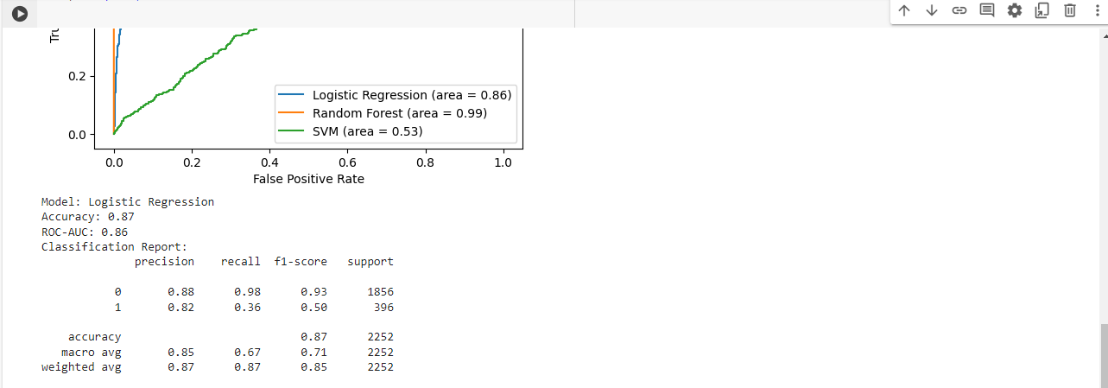

**Graph No. 5**

The ROC curve visualizes the trade-off between the true positive rate and false positive rate for the different thresholds of classification. Random Forest demonstrated the best area under the curve, indicating superior performance in distinguishing between the churned and retained customers.

Model Interpretation

Random Forest stands out as the most effective model for this task, providing high precision and recall, particularly notable in its ability to identify churned customers (which are typically the minority class in such datasets).

Gradient Boosting and Logistic Regression also provided valuable insights, though they might require further tuning or more complex feature engineering to reach the performance level of the Random Forest model.

**Business Implications**

The insights derived from the Random Forest model can guide targeted interventions to retain customers likely to churn. For instance, features that significantly influence churn predictions, such as Service_Score or Revenue_Per_Month, can be areas where the company focuses its customer satisfaction and retention strategies.

Predictive models can be integrated into the customer service workflows to identify at-risk customers early, allowing for proactive engagement and potentially averting churn.